MSIM 508

Introduction to Game Development

Programming Assignment #2

March 8, 2017

Mark Brosche

Major: MSVE - Master of Engineering

Online Distance Graduate - Outside Virginia (Saratoga Springs, NY)

[mbros006@odu.edu](mailto:mbros006@odu.edu)

407-325-2818

# **INTRODUCTION**

The assignment is to create a 3D game in Unity using the provided Tank model in which the player controls a tank, destroys enemies by firing shells, starting with a set hit point number of 20 that enemy bullets may decrease by one. The player must drive the tank, avoid/dispatch enemies as needed and find the level exit. Driving the tank should utilize my C# skills to realistically control the various functions like moving the turret, cannon, animating the wheels, etc. and not any of Unity’s tools for implementing vehicles. Additionally, part of making the game engaging is the ability for a player to see their impact on the virtual world and so implementing destructive effects such as ricochets, explosions, muzzle flashes, smoke, and sound effects will serve to enhance immersion and a sense of realism. These effects should be coupled with decreases in player or enemy life points and eventual enemy kills or losing the game. There should be two cameras which can be switched by pressing the F key, one to follow the tank and one to provide an overhead view. Also, the game should give the player the chance to replay a level if they are killed.

# **GAME DESIGN AND IMPLEMENTATION**

Files:

P2_Brosche_Mark.exe

# **CONTROLS**

W – move forward

A – steer left

S – move backward

D – steer right

Up – raise canon

Down – lower canon

Left – rotate turret left

Right rotate turret right

Space – fire shell

O – make all enemies fire bullets

R – restart level

Esc – quit game

# **CODE ARCHITECTURE**

**Class Diagram:**

I ran out of time to finish this section.

# ASSETS

Scripts:

TankController.cs

GameController.cs

GunController.cs

ShellController.cs

BulletController.cs

Models:

Tank

Outpost

RoundBunker

Big_Gun

Big_Base

Bullet

Materials:

Shell

Metal

Brown

Prefabs:

Tank

Tank Camera

Overhead Camera

BigExplosionEffect (Particle)

Boundary

Bullet

BulletImpactMetalEffect (Particle)

Canvas

Game Controller

ShellController

Shell

Outpost

RoundBunker

Big_gun

Big_base

MuzzleFlashEffect (Particle)

SmokeEffect (Particle)

Audio:

Boss Kill

Bullet Hit

Bunker Hit

Gun Shot

Shell Fire

Sniper Shot

Tank Death

Tank Engine

The_United_States_Army_Old_Guard_Fife_and_Drum_Corps_-_21_-_US_Army_Song_The_Caissons_Go_Rolling_Along

Victory_song

# RESULTS

# My results are below formatted as responses to the tasks set for the assignment:

1. Design a battle scene that has at least the following objects.
   1. Terrain.
      1. I used the Terrain tool to design two levels, with the second level designed to be more difficult than the first. I used the tool to place trees, draw differing textures such as sand, mountains, and pavement, and create a natural looking boundary with the raise/lower brushes. A Terrain Collider was automatically provided.
   2. Tank. You must use the tank model provided by the instructor. You need to generate a collider for the tank. A box collider is recommended for the tank.
      1. I used the tank model provided with a box collider.
   3. Still objects such as buildings and trees and your enemies are hidden in these objects. You can generate the models in Unity or obtain the models from other sources as described in next task. Generate necessary colliders for most objects in your scene.
      1. Trees were placed using the Terrain tool, but buildings were obtained from SketchUp. For the “Outpost” assets a box collider was used, for the “RoundBunker” a capsule collider, the “Big_Gun” a box collider, and “Big_base” several box colliders to achieve a hexagon shape and a capsule collider for the tower.
2. Obtain free or paid (at your own cost) 3D models from various sources. The following are some suggestions.
   1. Free models were obtained from SketchUp.
3. You need to use standard exported 3D files. Unity supports .FBX, .dae (Collada), .3DS, .dxf and .obj files, you need to convert your 3D models to one of these formats if necessary. You can use the following tools to convert your 3D models.
   1. No conversions were necessary to bring any of my selected models into Unity.
4. Generate an overhead camera that captures the entire scene and a third person camera for the tank controlled by the player. The two camera views can be switched by pressing the F(f) key.
   1. The Game Controller script manages the switching between cameras. When the f key is pressed, one camera is disabled while the other is enabled, avoiding the need to disable an audio listener on one of them.

Game play

1. The overall goal is to shoot your hidden enemies, which can also shoot you from different locations.
   1. The game achieves this by destroying enemy bunkers of varying sizes by controlling the tank.
2. The player controls her/his own tank using the following keys: W (move forward), S (move backward), A (turn left), D (turn right), Left (rotate turret left), Right (rotate turret right), Up (raise cannon), Down (lower down cannon), Space (fire).
   1. These controls are implemented as required in the TankController script.
3. Write a script to control the tank movement. Note that front and rear wheels have different sizes and thus they must rotate at different speeds. The front (steering) wheels must not deviate from their central positions for more than 45 degrees. Similarly, the cannon must move in the range from its reset position to 90 degrees vertically. Note that you cannot use the Wheel Collider provided by Unity in this assignment.
   1. These controls are implemented as required in the TankController script. Additionally, I calculated an approximate ratio for how much the tank should rotate given the angle of the front steering geometry, but found that it made the turning radius too large. Angles for the canon and steering geometry are limited with the Mathf.Clamp function.
4. The shells fired by your tank (by pressing spacebar) should follow a trajectory determined by a projectile motion. Enemy fires can follow projectile motions or straight line motions depending on their ammunitions. Add sound effects for the shells and enemy ammunitions.
   1. The shells fired by the tank are governed by the ShellController.cs script. When ‘space’ is pressed, a shell prefab will spawn at the end of the canon with a Vector3.forward trajectory and adjustable speed variable. Because velocity is applied to the shell rigid body and gravity is turned on, it travels in an arc. On firing, the shell also plays an audio source (from freesound.org) and muzzle flash particle prefab from the Unity Particle Pack. On collisions with other colliders, the shell will play an impact prefab and then destroy itself.
5. Write a script to control the enemy fires. Enemy fires occur only when your tank appears within a certain range from the enemy in terms of distance and direction (angle). Enemy fire speed and frequency should be adjustable as well.
   1. The bullet prefab behaves similarly to the shell prefab, except for its trajectory, which does not follow an arc. Unfortunately, I was not able to complete the code for scanning the area for the player within a set angle and range, nor to a set rate of fire. Fire speed is adjustable in the inspector.
6. When an enemy fires a bullet, the orientation of the bullet must be consistent with its traveling direction, i.e., its motion must be longitudinal.
   1. Bullets fire on ‘o’ key press. The bullets are oriented along their appropriate trajectory, which is set by an empty game object ‘gun’.
7. Generate a Unity prefab for the tank shells and use that prefab in your game. Similarly generate prefabs for other necessary game objects.
   1. A shell prefab was created, as well as a prefab for the ShellController.cs script (an empty GameObject) so that shells could be instantiated without stuffing more code into the TankController.cs script.
   2. I generated prefabs for everything, which may not have been necessary.
8. Use particle system to simulate the fire and smoke in shell explosions.
   1. When enemy bunkers receive collisions with ‘shell’ tagged objects, they play an impact sound and when enemy life reaches zero, the Kill() function instantiates an explosion prefab and a smoke prefab before destroying itself. Particles are instantiated at the location of the collision.
9. Your tank has a life of 20, that is, it will die after being shot for 20 times. Your enemies only have a life of 3, that is, they will die after being shot three times.
   1. Tank and enemy health are managed in the TankContoller.cs and GunController.cs scripts respectively. When the tank dies, the Tank is un-parented from the tank camera so the player can watch the explosion and see the tank destroyed.
10. Display the lives of the player (tank) remaining and press key R(r) to restart the game.
    1. Tank Health is displayed in the lower left corner of the screen and counts down to 0. When the health reaches zero the lose game text appears and prompts the player to press ‘r’ to try again or ‘esc’ to quit.
       1. 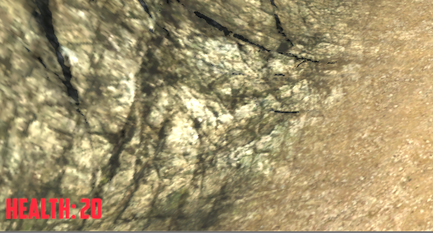
       2. 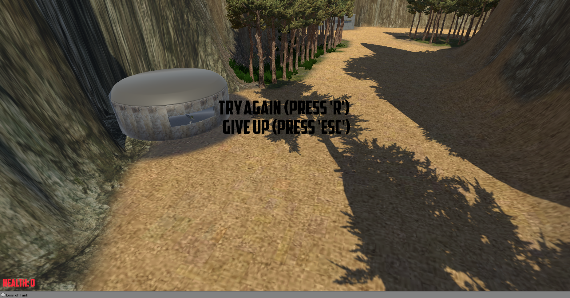
       3. 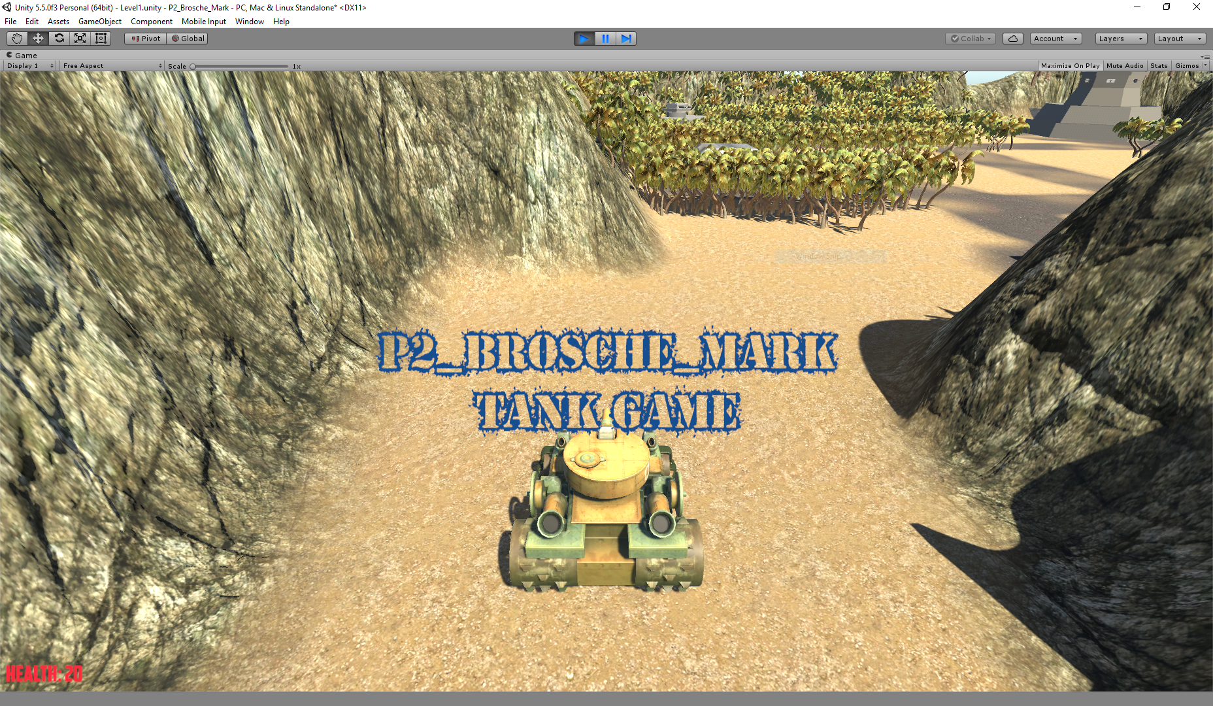
11. Generate different folders for different types of assets in your games.
    1. Please see the Folder “Assets” in the project directory.

# IMPORTANT SCREEN CAPTURES

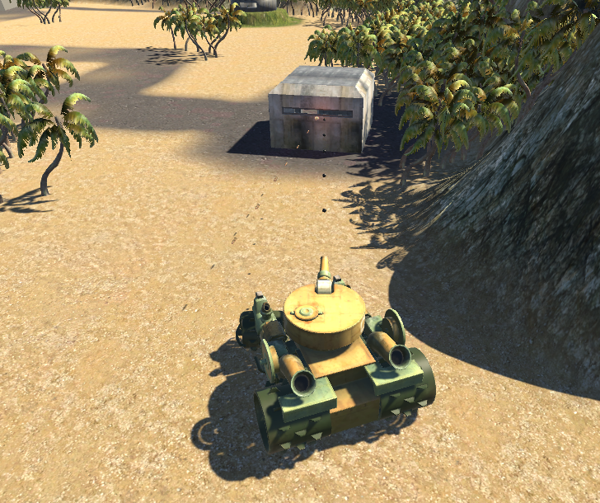

**The Tank and Outpost enemy exchanging fire.**

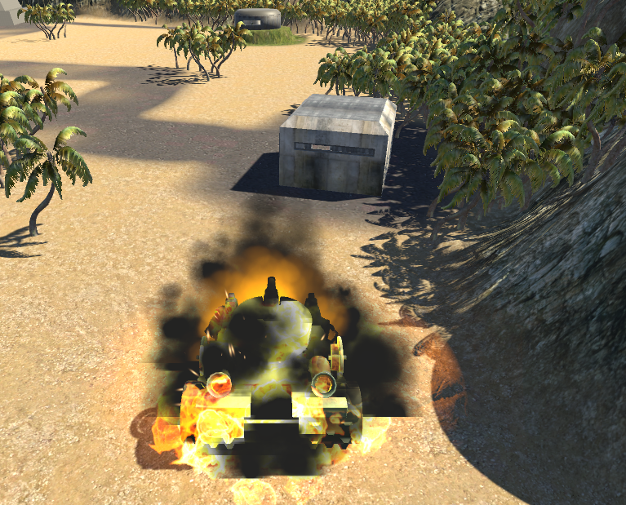

**The Tank explodes when health is zero.**

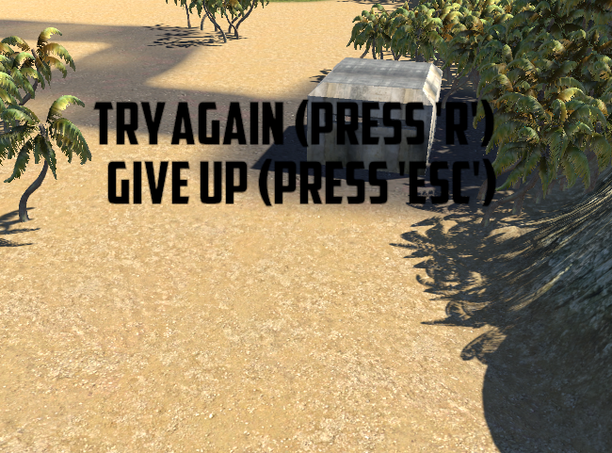

**Text appears when you die.**

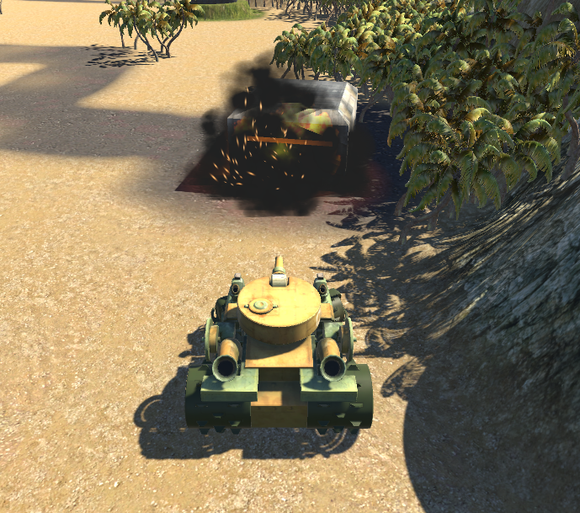

**Enemies explode after 3 hits.**

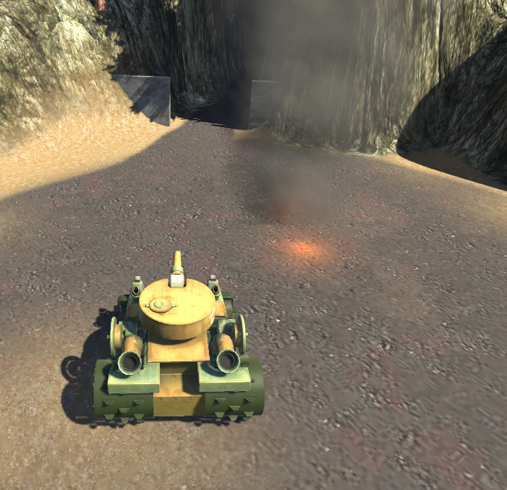

**Smoking remains of Big_base**

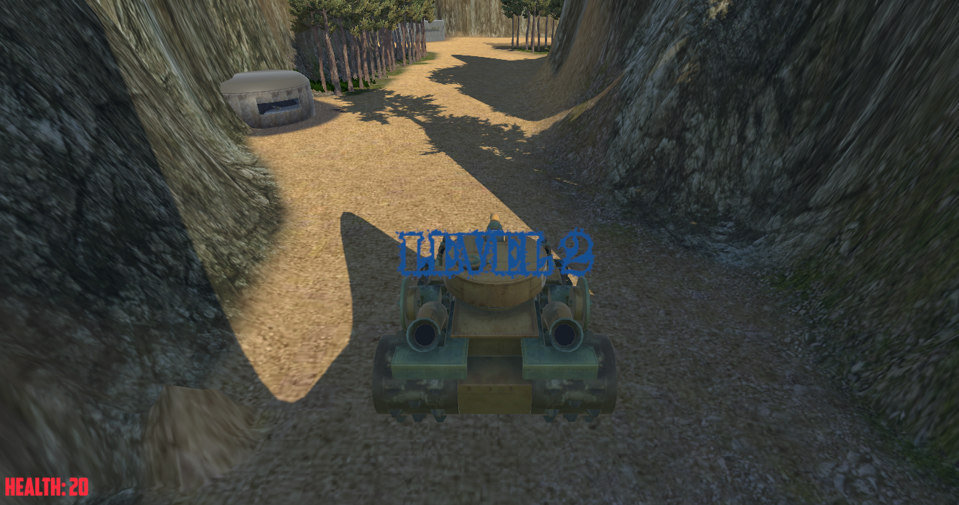

**Level 2 Intro text**

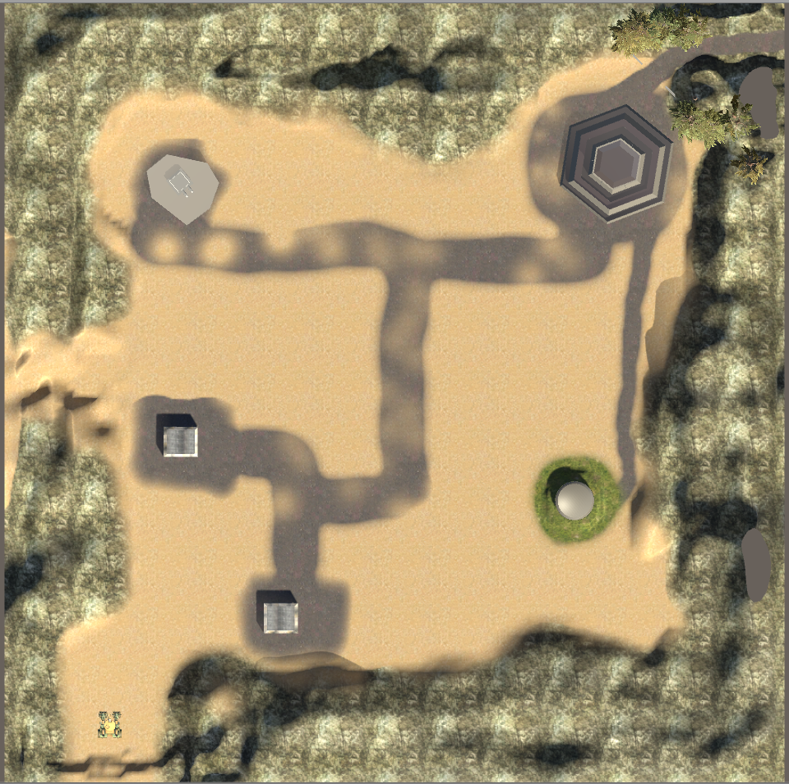 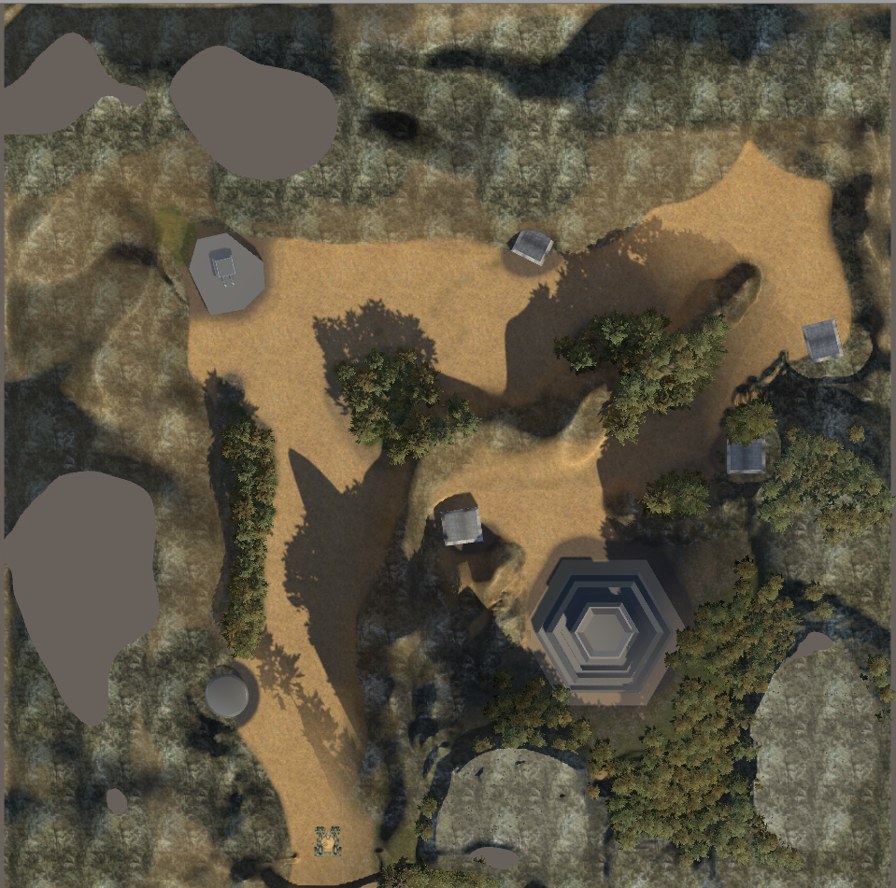

**Overhead Camera Views: Level 1 (Left) and Level 2 (Right)**

# CONCLUSION AND DISCUSSION

This is my first playable Unity game so it’s fair to say I’ve learned a lot; I would say 90% of what I did was completely new to me. Using the terrain tool, instantiating and destroying objects, and creating vehicle controls were just a few of the things that were new to me. I still need to implement the enemy functions to search for and fire bullets at the player, unfortunately I was not able to complete that code in time. Overall, my code is messy and inconsistently implemented. Some things I know I could work better are the control scripts for bullets and shells; using empty game objects seemed like a dirty way to get around my problems with the destroy function. I also had trouble trying to use the WaitForSeconds function to make events flow the way I intended. I’ve probably spent 30+ hours on this assignment, with learning many things as I created and tested them slowed me down quite a bit.